**COMPUTER GRAPHICS**

**MINI PROJECT**

**Group Members:**

17CO39 - Nathani Aamir HAneef

17CO53 - Huzefa Surme

17CO38 – Aamir Sabri

**Topic :**

**BOUNCING BALL USING OPENGL**

**OBJECTIVE :**

To implement various opengl functions to get output of

Bouncing Ball.

**INPUT:**

In this program we don't have to provide any input because when we run the program, a window appears with a Bouncing Ball.

**OUTPUT:**

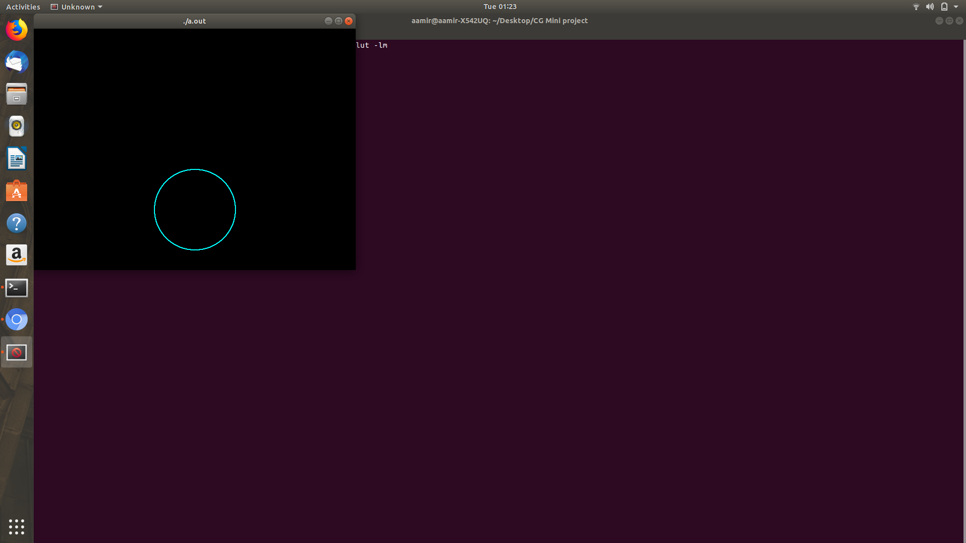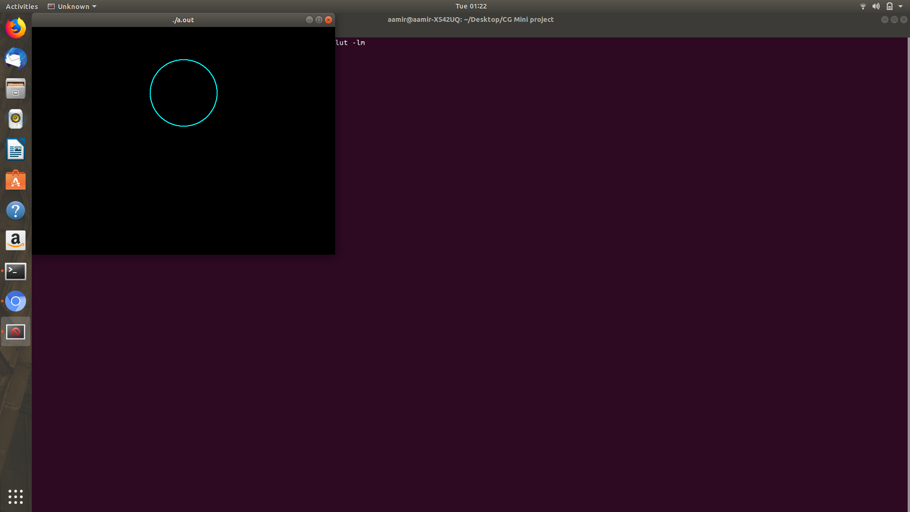

**REFERENCE:**

1- www.opengl.org

2- www.youtube.com

3- www.opengltutorial.com

**CONCLUSION:**

In this mini project we have implemented a moving boat program in OpenGL using various OpenGL functions. We have understood the concept of OpenGL and the various functions of OpenGL.

**CODE:**

#include <GL/glut.h>

#include <GL/gl.h>

#include <GL/glu.h>

#include <math.h>

#include <stdio.h>

#include <string.h>

#define WIDTH 640

#define HEIGHT 480

void reshape(int width, int height)

{

glViewport(0,0,width,height);

glMatrixMode(GL_PROJECTION);

glLoadIdentity();

glOrtho(-WIDTH/2,WIDTH/2-1,-HEIGHT/2,HEIGHT/2-1,-1,1);

glMatrixMode(GL_MODELVIEW);

glLoadIdentity();

}

void init(void)

{

glClearColor(0.0,0.0,0.0,1.0);

glPointSize(2.0);

}

void Timer(int ex)

{

glutPostRedisplay();

glutTimerFunc(30,Timer,0);

}

int k=20;

void circle(int p,int m)

{

int x=0,y,d,r;

r=m;

y=r;

d=3-2*r;

while(x<=y)

{

glVertex2i(x,y+p);

glVertex2i(y,x+p);

glVertex2i(-x,y+p);

glVertex2i(-y,x+p);

glVertex2i(-x,-y+p);

glVertex2i(-y,-x+p);

glVertex2i(y,-x+p);

glVertex2i(x,-y+p);

if(d<0)

d=d+4*x+6;

else

{

d=d+4*(x-y)+10;

y--;

}

x++;

}

}

int r=100,flag=0;

void display(void)

{

glClear(GL_COLOR_BUFFER_BIT | GL_DEPTH_BUFFER_BIT);

glColor4f(0.0,1.0,1.0,1.0);

glBegin(GL_POINTS);

circle(k,r);

if(flag==0)

{

if((k+r)<=240)

{

k=k+10;

}

if((k+r)>=240){

flag=1;

}

}

if(flag==1)

{

k=k-10;

if((k-r)<=-240)

{

flag=0;

if(r!=10)

r=r-10;

}

}

glEnd();

glutSwapBuffers();

}

void idle(void){

}

int main(int argc, char **argv){

glutInit(&argc,argv);

glutInitDisplayMode(GLUT_DOUBLE | GLUT_RGBA | GLUT_DEPTH);

glutInitWindowPosition(0,0);

glutInitWindowSize(WIDTH,HEIGHT);

glutCreateWindow(argv[0]);

init();

glutIdleFunc(idle);

glutReshapeFunc(reshape);

glutDisplayFunc(display);

glutTimerFunc(0,Timer,0);

glutMainLoop();

return(1);

}